SCHWARZ WELLNESS CENTER

CLIENT INTAKE FORM

Please Print Date:

Name: _____________________________ Home #: ( )_______________________
Address: _____________________________ Work #: ( )_______________________
City/State/Zip: _____________________________ Cell #: ( )_______________________

Email Address: (block print please):_____________________________________________________________

Chief Complaint that brought you here?: __________________________________________________________

Sex: ____ Height: ______ Weight: _______ Age: ____ Date of Birth: ___________Married or Single: _____

Occupation: _______________________________ Referred by: ___________________________________

Religious Affiliation: _____________________ Do you attend a church regularly and have a church family:_______

List of Medications: _________________________________________________________________________

Any organs removed? If so, which ones: __________________________________________________________

Have you ever had an Anaphylaxes Reaction in your life? _____ Yes ______No (if Yes) to what? _______________

Have you ever had or been diagnosed as having problems with any of the following:

[ ] Anemia [ ] Kidneys [ ] Hypoglycemia [ ] Weight [ ] Cancer

[ ] Fainting [ ] Bleeding [ ] Allergies [ ] Diabetes [ ] Menopause

[ ] Prostate [ ] Ovaries [ ] Lungs [ ] Asthma [ ] Ulcers

[ ] Heart [ ] Arthritis [ ] Hiatus Hernia [ ] Coffee [ ] Thyroid

[ ] Heart Burn [ ] Breast [ ] Skin/Acne [ ] Headaches [ ] Burping/Gas

[ ] Bloating [ ] Spleen [ ] Gallbladder [ ] PMS [ ] Edema

[ ] Fibromyalgia [ ] Pancreas [ ] Tumors [ ] High Blood Pressure

[ ] Stroke [ ] Heart Attack [ ] Seizures [ ] Migraines [ ] Low Blood Pressure

[ ] Numbness in hands/feet

Is there any other aspects of your health history which we should be aware of, please indicate: ___________________

_______________________________________________________________________________________

Please list diseases or conditions which your parents and grandparents have or had:

Grandmother:_____________________________________________________________________________

Grandfather: _____________________________________________________________________________

Mother: _________________________________________________________________________________

Father: _________________________________________________________________________________

What time do you normally go to bed: ____________ What time do you wake up in the morning: _____________

Do you wake up rested: _______________________ Do you sleep sound/without interruptions: _____________

Describe your normal meals:

Breakfast: _______________________________________________________________________________

Lunch: _________________________________________________________________________________

Dinner: _________________________________________________________________________________

Snacks: ________________________________________________________________________________

Please list your normal day’s intake of the following:

Water: ________________ Alcohol: _______________ Coffee/Tea: _________________

Juice: ________________ Soda: ________________ _ Diet Drinks: _________________

What type of water do you drink? ______________________________________________________________

How many bowels movements do you have a day: ________________

Describe your energy level: __________________________________________________________________

What is your favorite food? ___________________________________________________________________

Client’s Signature: ____________________________________________________________________

Name and address of legal guardian if client is a minor:

Relationship to minor: ______________________________________________________

Name: ________________________________________________________________________________

Address: ______________________________________________________________________________

Contact telephone number: _____________________________________________________________

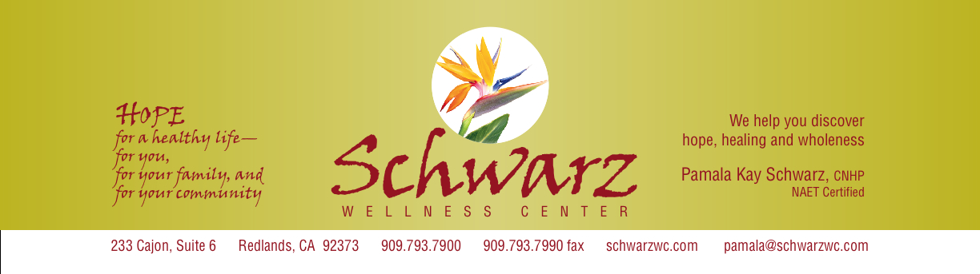
555 Cajon, Suite F Redlands, California 909.793.7900 909.793.7990 Fax schwarzwc.com pamala@schwarzwc.com

I understand this consultation is $225 due and payable today and is not covered by insurance.

Signature_______________________________

Date:___________________

CANCELLATION POLICY

We understand that sometimes you need to cancel or reschedule an appointment. Your appointment time has been specifically reserved for you and when it is missed, that time cannot be used to treat anyone else.

If you are unable to keep your appointment, please provide at least 24 hours notice. Appointment times are both limited and in high demand, someone else may be seen if appropriate notice is provided. Our answering machine is on 24 hours a day for this purpose.

There will be a $15 charge if you cancel with less than a 24 hours notice or if you do not show. You will be considered a “no show” at 15 minutes after your scheduled appointment time.

If you will be late for your appointment, we ask that you notify us of the delay as soon as possible.

Patient Signature

Print Patient Name

Date

Schwarz Wellness Center
555 Cajon Street, Suite F
Redlands, Ca 92373
909-793-7900

1. I understand that Pamala Kay Schwarz is a traditional Naturopath and not a licensed physician. I understand that Traditional Naturopaths are not licensed by the State of California. Therefore, the services I receive from Schwarz Wellness Center and Pamala Kay Schwarz are not licensed by the State of California.

2. I understand that the services I receive from Schwarz Wellness Center and Pamala Kay Schwarz is alternative or complementary to the healing arts services licensed by the state. I understand that Schwarz Wellness Center and Pamala Kay Schwarz is not a medical facility or medical doctor and I am encouraged to check with my primary physician prior to and during any alternative or complimentary unlicensed treatment.

3. I understand that Schwarz Wellness Center and Pamala Kay Schwarz provides services to help with proper nutritional absorption which is required by the body in order to achieve the highest level of health possible. Schwarz Wellness Center and Pamala Kay Schwarz uses lifestyle changes, nutritional supplements, behavior modification, general health education and information along with the allergy elimination technique in order to achieve this goal.

4. I understand that Pamala Kay Schwarz graduated with a degree in Traditional Naturopathy from Trinity College of Natural Health. She also is a Certified Natural Health Care Practitioner, and has an advanced certification in the technique of NAET (Nambudripad’s Allergy Elimination Technique). I understand that NAET is not a licensed procedure by the State of California.

5. I understand that Schwarz Wellness Center strongly believes that when the body is provided with the needed allergy free nutrition, it can then reach a level of balance to help combat weakness and disorder.

6. I understand and acknowledge that Schwarz Wellness Center, Pamala Kay Schwarz and/or any employee or representative of Schwarz Wellness Center cannot and has not provided me with any guarantee or promise of good or improved health as a result of their service and or treatment.

7. I have received a copy of this acknowledgement for my personal file and hereby sign that I understand all of the language stated herein.

Print Name:_____________________________________ Date:___________________

Signature: _________________________________________________________

Schwarz Wellness Center
555 Cajon Street, Suite F
Redlands, Ca 92373
909-793-7900

1. I understand that Pamala Kay Schwarz is a traditional Naturopath and not a licensed physician. I understand that Traditional Naturopaths are not licensed by the State of California. Therefore, the services I receive from Schwarz Wellness Center and Pamala Kay Schwarz are not licensed by the State of California.

2. I understand that the services I receive from Schwarz Wellness Center and Pamala Kay Schwarz is alternative or complementary to the healing arts services licensed by the state. I understand that Schwarz Wellness Center and Pamala Kay Schwarz is not a medical facility or medical doctor and I am encouraged to check with my primary physician prior to and during any alternative or complimentary unlicensed treatment.

3. I understand that Schwarz Wellness Center and Pamala Kay Schwarz provides services to help with proper nutritional absorption which is required by the body in order to achieve the highest level of health possible. Schwarz Wellness Center and Pamala Kay Schwarz uses lifestyle changes, nutritional supplements, behavior modification, general health education and information along with the allergy elimination technique in order to achieve this goal.

4. I understand that Pamala Kay Schwarz graduated with a degree in Traditional Naturopathy from Trinity College of Natural Health. She also is a Certified Natural Health Care Practitioner, and has an advanced certification in the technique of NAET (Nambudripad’s Allergy Elimination Technique). I understand that NAET is not a licensed procedure by the State of California.

5. I understand that Schwarz Wellness Center strongly believes that when the body is provided with the needed allergy free nutrition, it can then reach a level of balance to help combat weakness and disorder.

6. I understand and acknowledge that Schwarz Wellness Center, Pamala Kay Schwarz and/or any employee or representative of Schwarz Wellness Center cannot and has not provided me with any guarantee or promise of good or improved health as a result of their service and or treatment.

7. I have received a copy of this acknowledgement for my personal file and hereby sign that I understand all of the language stated herein.

Client Copy
Print Name:_____________________________________ Date:___________________

Signature: _________________________________________________________

